Git link : https://github.com/EMGPPT/prog7311-g3-2026-poe-ST10443092
Video link: https://youtu.be/gmj8bE6KaLA
Docker setup/compose (in the same file director): docker-compose up --build
**Should the link not work the vide will also be uploaded

Docker Containers
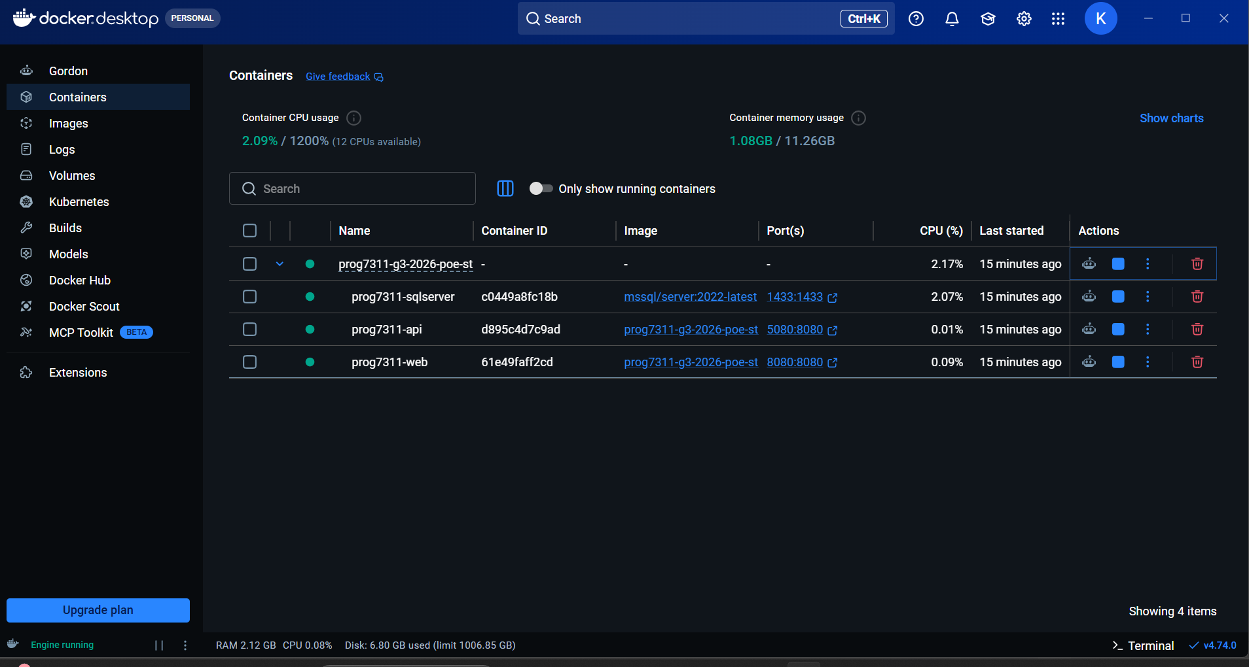

Technical report
Automated testing plays an important role in CI/CD process as it ensures that any new changes to code are not breaking the current application before it goes into deployment. The automated testing feature allows me to test such features as PDF only contract uploads, currency conversions from USD to ZAR, and redirection after logging in according to user roles in my application. For example, if I make changes to my code that will affect one of the above mentioned features and the test fails, it will not proceed to the deployment stage. Automated testing is therefore an important quality gate in terms of giving developers immediate feedback regarding the quality of the product before releasing it to consumers. Shahin, Babar and Zhu (2017) state that continuous integration, delivery and deployment facilitate software releases by providing such practices as automated testing, build feedback, and fault detection.

Another way in which automated testing can help avoid bugs in production is through consistent verification of expected behavior. In contrast to manual testing, which may take a long time and be hard to remember to perform, automated testing can be performed every time that some code is committed. Automated testing is helpful in identifying regression bugs because every commit can be verified against previous tests to make sure that existing behaviour has not changed unintentionally. In case the file type validation for the contract upload failed to reject non-PDF files or the redirection after the login on behalf of a client to the ClientService/Index did not work, the test would have detected such bugs much earlier than manual testers and end users.
Containerization is also critical since it makes it possible to maintain consistency of the application environment across all stages of the process. By packaging the application, its runtime environment, system utilities, and dependencies, Docker makes it possible to use the same application environment on different computers (Docker, 2026a). Thus, the well-known problem with software working fine on developers’ machines but failing to work properly anywhere else becomes easier to address because the container does not have to rely solely on what is available on a developer’s PC. For instance, if I were to deploy an ASP.NET Core MVC application that relies on a particular version of .NET, SQL Server connection configuration, and API-related dependencies, these would no longer be an issue.
Another aspect of consistency that is supported by Docker involves isolation and portability. Containers have been defined by Docker as comprising everything needed for running applications and can be easily distributed to allow users to access the same development environment (Docker, 2026b). This enables the application to be tested in an environment which is similar to the production environment prior to deploying the code into the production environment. In doing so, this eliminates any problems that might arise due to configuration issues, missing dependency issues, or differences in the version of the runtime environment used during application development.

References

Docker, 2026a. What is a container? Available at: https://www.docker.com/resources/what-container (Accessed: 25 May 2026).
Docker, 2026b. What is Docker? Available at: https://docs.docker.com/engine/docker-overview/ (Accessed: 25 May 2026).
Shahin, M., Babar, M.A. and Zhu, L., 2017. Continuous integration, delivery and deployment: a systematic review on approaches, tools, challenges and practices. IEEE Access, 5, pp.3909–3943. Available at: https://doi.org/10.1109/ACCESS.2017.2685629.

